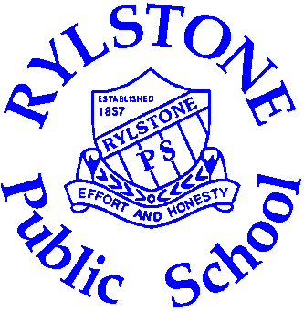
School Team Sports Selection Policy

Preamble
Sport is conducted at Rylstone Public School under the auspices of the DET School Sport Unit. The School Sport Unit promotes and supports the implementation of appropriate sport and sport-focused programs for all students by encouraging participation, skill development and excellence in performance.
Rylstone Public School wishes to encourage all students to participate in school sport. Participation provides skill development, exercise and valuable social interaction while teaching respect and sportsmanship.

Policy
- All sporting teams are to be selected, coached and managed by a current teacher at Rylstone Public School (RPS). This teacher is responsible for the conduct of the students in the team and the selection of the team.
- Members of the public, parents or guardians of students may be appointed, at the discretion of the teacher in charge, to act as skills assistant. Their role is to provide coaching and technical assistance to those students selected by the teacher in charge or trying out for a team. Those not directly employed by the school may be required to complete a “Working with children declaration” prior to involvement as skill assistants.
- All students selected in a team sport representing Rylstone PS will be expected to conduct themselves in a fair and sportsman like manner while training for and participating in the sport. Particular regard is given to respect for coaching staff, fellow team members and opposition team members. Failure to demonstrate this respect will jeopardise a place on the team and selection in future RPS teams.
- All School staff and parents who accompany Rylstone PS teams are also expected to conduct themself in a fair and sportsmanlike manner.
- Selection in competitive sporting teams is open to any eligible student wishing to participate in a particular sport. Selection is merit based, criteria being the ability and skill level of students in that particular sport.
- The selection of competitive teams is the responsibility of the teacher in charge of that team. Their professional judgement and decisions are to be respected by all members of the School community.
- Non competitive sport competitions will be open to all students wishing to nominate with preference always going to Years 5 & 6 students and then filled by class seniority in the school.
- General school behaviour, attitude and performance are taken into account when selecting both competitive and non-competitive teams.
- In the case of Zone selection trials please refer to the Cudgegong Zone Selection Policy.
- The teacher in charge will, where possible, communicate to the school community which sports are competitive or non competitive.

School Council
2010

